

**Khulna University**

Software Requirements Specification

for

Diagnostic Center Management

Version 1.0

8 November, 2020

**Sujan Kumar Dhali , Student ID : 190213**

**Tanvir Hasan , Student ID : 190208**

**Table of Contents**

**1 Introduction**

1.1 *Documentation Purpose*………………….……………...06

1.2 *Diagnosis Information Acquisition* ………………....06

1.3 *Scope of the product* …………………..………………....07

1.4 *Intended Audience and Reading Suggestions* ....07

*1.5 References …………………………*……………………………...….08

***2 Overall Description***

*2.1 Product Perspective*………………….……………………..08

*2.2 Functionality* …………………………………………………………….08

*2.3 Architectural Design…………..*……………..…………....09

*2.4 Sequence Diagram………*………….……………………...09

*2.5 Database Design*………………………..…….…………..…10

*2.6 Logical Design……………………………………………….…10*

*2.7 User Classes and Characteristic……………….…….…10*

*2.7.1.Administrators Module………………………..….11*

*2.7.2.Receptionist Module……………………………..…11*

*2.7.3.Doctors Module……………………………………..…11*

*2.7.4.Patients Module……………………..….………….…11*

*2.8 Operating Environment…………….….………….…12*

*2.9 Design and Implementation Constraints….…12*

*2.10 User Documentation…………..……………………12*

***3 Specification Requirements***

***3.1 External User Interface Requirements****…………..*12

*3.1.1 Home Page…………………………………..……….13*

*3.1.2 Sign in Form…..……………………………...……..13*

*3.1.3 Sign Up Form………………………………………...14*

*3.1.4 Appointment Booking System(Both for*

*Admin and Receptionist…………………………….14*

*3.1.5 Hardware Interfaces……..……..……………….15*

*3.1.6 Software Interfaces………………………………..15*

*3.1.7 Communications Interfaces…….………………15*

***3.2 System Features****……………………………..………………..16*

*3.2.1 Description and Priority……………………………16*

***3.3 Functional Requirements****………….……………………….16*

*3.3.1 Patient Management……………………………….16*

*3.3.2 Appointment Scheduling…………………………..16*

*3.3.3 Doctors Management………….…………………..17*

*3.3.4 Billing System…………………….…………………….17*

***3.4 Behavior Requirements****……………….……………………18*

***3.4.1 Use Case View****……………….…………………………….18*

***3.4.1.1.1 Individual Actor****……………….………………….19*

*3.4.1.1.1 Patients……………….……………………………19*

*3.4.1.1.2 Admin……………….…………………………….19*

*3.4.1.1.3 Doctors……………….…………………………..20*

*3.4.1.1.4 Test Department……………….…………….20*

*3.4.1.1.5 Receptionist……………….……………………21*

*3.4.1.2 Patients Use Case……………….……………………22*

*3.4.1.3 Admin Use Case……………….……………………..22*

*3.4.1.4 Doctors Use Case……………….……………………22*

*3.4.1.5 Test Department Use Case……………….………22*

*3.4.1.6 Receptionist Use Case……………….……….…….23*

***4 Other Non-functional Requirements****……………….….23*

*4.1 Performance requirements…………………….………23*

*4.2 Safety requirements…………………………..….………23*

*4.3 Security Requirements………………….……….………24*

*4.4 Software Quality Attributes…………….…….………24*

*4.5 Business Rules……………………………..……….………24*

*4.6 Maintenance…………………………….………….………24*

***5 Other Requirements****…………………………….…………..25*

***1 Introduction***

**1.1 Documentation Purpose**

A Diagnostic Center Management System integrates all the data relating to patients,doctors,staff,hospital body details etc.The system provides Diagnostic Center with efficient solution which manage appointments,registration,billing system,medication management,various types of testing,booking doctors and so on.It provides fully integrated customized and user friendly solution designated to address all the functionalities in a Diagnostic Center.In a Diagnosis expert system(DExS) can help a great deal in identifying diseases and describing methods of treatment to be carried out taking into account the user capability in order to deal and interact with expert system easily and clearly.

**1.2 Diagnosis Information Acquisition**

The data and knowledge of DExS are collect from different sources.The first primary source is the medical knowledge of expert doctors.The second source is from specialized databases,books and few electronic websites.

**1.3 Scope of the product**

The proposed Diagnostic Management System will be used to covers diagnosis management system development.It is limited to the development of database application that can be used to register medical knowledge of corresponding symptoms,disease and prescription to database for use in diagnosing patients.It can replace the current system paper-based system by a very faster system.For system maintenance the developers or operators can work here. It makes an opportunity both for the employees and organization.

**1.4 Intended Audience and Reading Suggestions**

This Software Requirements Specification document is intended for software engineers, system testers, software designers in developing, testing, and producing the safety and health management system and is for everyone who is somehow related with this project. It is suggested to read the sections sequentially, and to reference the appendices as one progresses, in order to clarify jargon terms and definitions and reach out the basic requirements. The developer or admin can read this documentation for future use or maintenance. Users and other external entities can read this documentation to know its terms and conditions.

***1.5 References***

<https://www.projecttopics.org/diagnosis-management-system-development.html>

<https://codecanyon.net/item/lab-management-system/15477308>

[https://colorlib.com/preview/#medcare](https://colorlib.com/preview/" \l "medcare)

https://abdulsdoc.files.wordpress.com/2015/03/software-requirement-specification-hospital-management-system.pptx

***2 Overall Description***

***2.1 Product Perspective***

This Diagnostic Center Manage System is a self contained system.It manages activities and reactions between hospital authorities and patients.Various types of stakeholder are also included in this system.It also provides patients health care.

***2.2 Functionality***

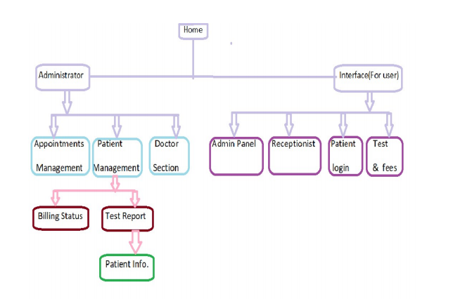

***2.3 Architectural Design***

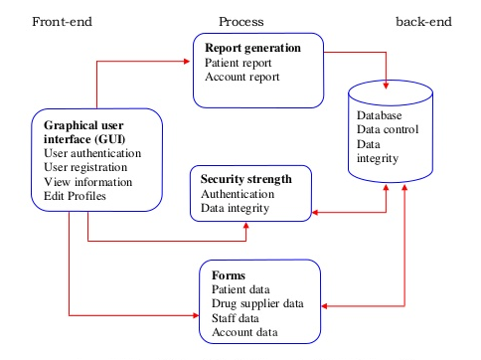

***2.4 Sequence Diagram***

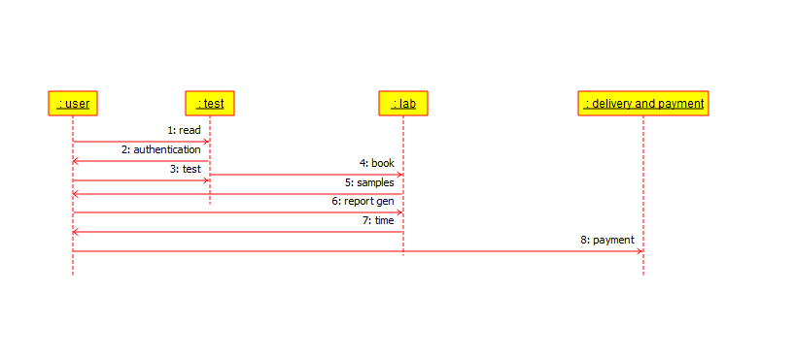

***2.5 Database Design***

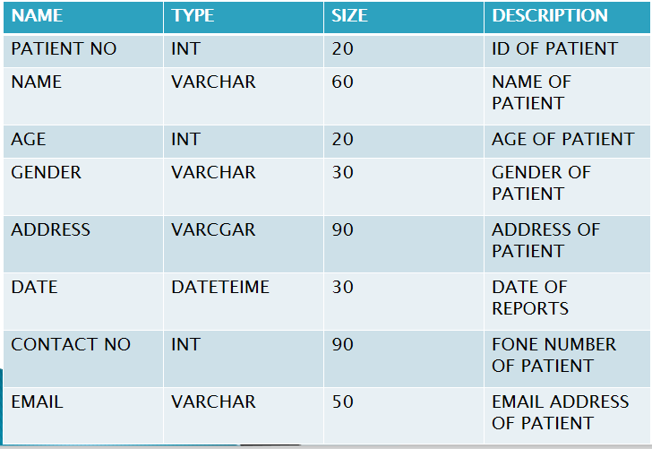

***2.6 Logical Design***

1. *The proposed information system contains the following data tables in its database collection.*
2. *Patient Details table*
3. *Doctor Details Table*
4. *Room Details Table*
5. *Bill Details table*

***2.7 User Classes and Characteristics***

The entire Diagnostic Management System suite program has a set of users, each with different security

privileges. It contains the interfaces of various manipulation and operations which are our basic target

perform and giving the clients an efficient solution.. The characteristics aim at implementing the interfaces of

the requirements. These user types are-

***2.7.1.Administrators Module:***

* *Control Log in info.*
* *Add/Remove Receipient*
* *Edit/Update info*
* *Authentication*
* *Appointment of Doctors*
* *Add/remove Doctors/Receptionist*

***2.7.2.Receptionist Module:***

* *Patients Registration*
* *Provide Information*
* *Edit/Update info*
* *Schedule Patient Appointment*

***2.7.3.Doctors Module:***

* *Sign in /Sign up*
* *Appointment Schedule*
* *Prescribe Test*

***2.7.4.Patients Module:***

* *Sign in /Sign up*
* *Test information and Fees*
* *Request Appointment*
* *Payment*

***2.8 Operating Environment***

As it is a web based application,this system is compatible with any browser(suggested for using any updated browser), using in a desktop environment.There is specially designed for windows only.

***2.9 Design and Implementation Constraints***

This system hasn’t any developers support options.A lower performance hardware is suggested to avoid due to low quality performance.Sometimes the performance may be slow or takes time as many users access the system at a time.

***2.10 User Documentation***

User documentation defines how to use this system.In user manual providing video tutorial and some online help for user get rid of any problem.

***3 Specification Requirements***

**3.1 External User Interface Requirements**

The system has all the requirements that the user needed.User can visit the site to get any related information what they want to know but cannot edit or change it according their want,as they don’t have that right.The system will take the user in the home page and welcome the user after loading the page.This can also switch different pages from any page.There will also Log in and Log out system for easily access this system.There is also Sign Up facilities for new user.

***3.1.1 Home Page***

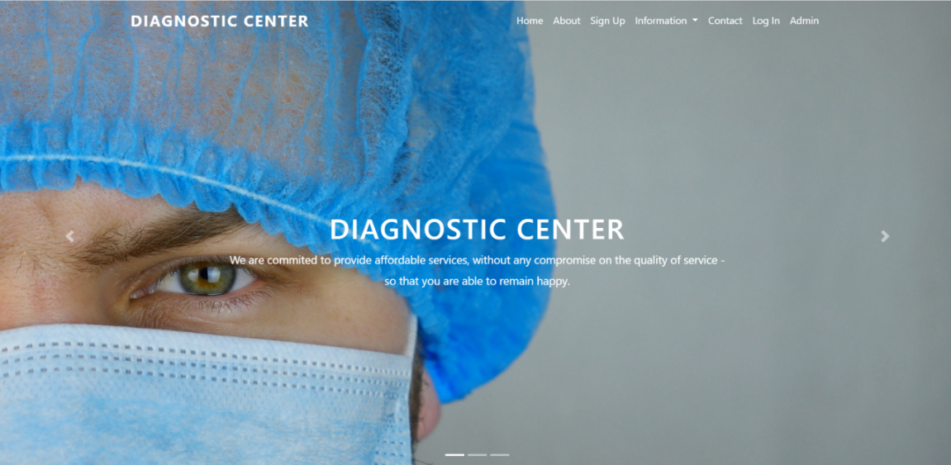

***3.1.2 Sign in Form***

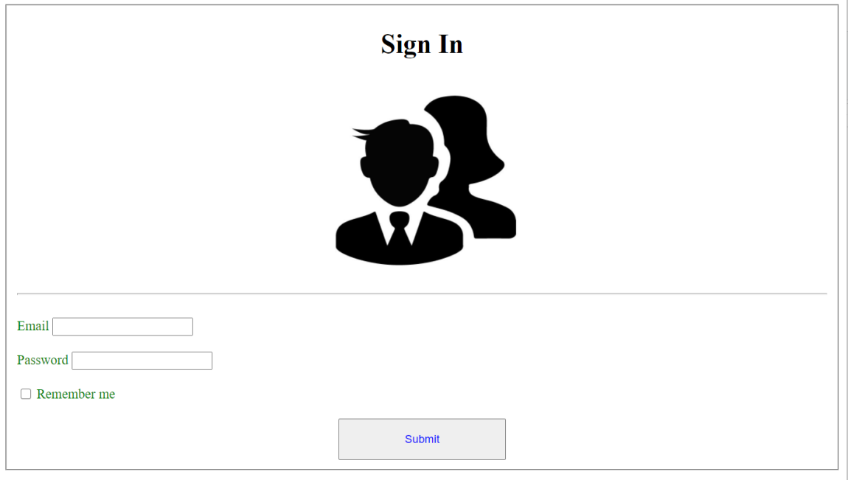

***3.1.3 Sign Up Form***

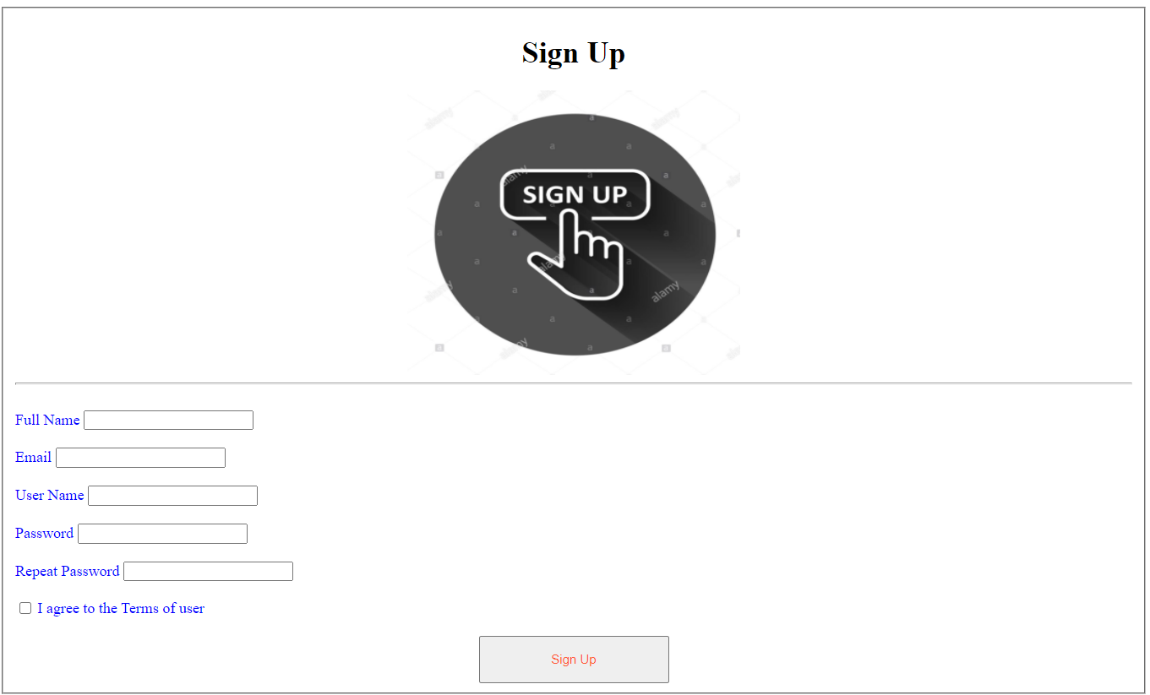

***3.1.4 Appointment Booking System(Both for Admin and Receptionist)***

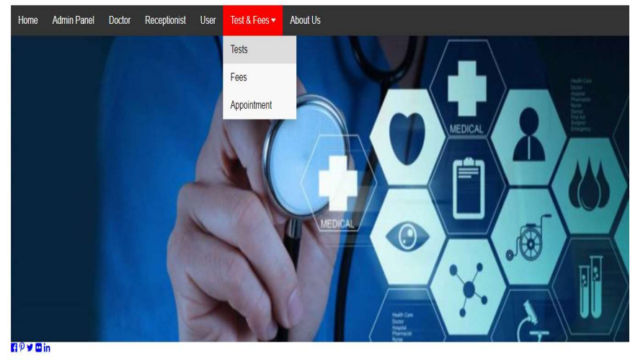

***3.1.5 Hardware Interfaces***

All components able to be executed on personal computers

• Processor : Pentium II,Pentium III,Pentium IV or Dual-core CPU.

• Hard-disk : Minimum 5MB

• RAM: 64 MB

***3.1.6 Software Interfaces***

The system should be designed in this way that it is accessable from any kinds of software settings.The software interface should collect the information that the user needs.It will interface with standard Windows API and GUI. Data that will be shared between computers and instance of the software being run will be pushed and pulled from the patient database as needed/requested. This database can be configured and deployed for usage in case-specific usages for each hospital network that uses the software in its own LAN or intranet. All offline and online access will be monitored, for transparency purposes, and in order to reduce abuse and unauthorized access of the system.

• Operating System : Win-98,Win-XP,Linux or any other higher version

• Database : SQL,MS Access

***3.1.7 Communications Interfaces***

We can conceive of all the information that gets exchanged in Diagnostic Center. The communication space is that portion of the total number of information transactions that involves interpersonal interaction. For example, user-admin conversations, telephone calls, letters and e-mail all generate transactions that would fall into the communication space.This project can also compatible with all platforms. Connections to the system will be over TCP/IP connection, project supports all types of web browsers. Simple mail transfer protocol/ Hypertext transfer protocol for generating emails of reports from the software. FTP can also be used in pushing generated document reports to a hospitals FTP server.

***3.2 System Features***

***3.2.1 Description and Priority***

This is designed for managing diagnostic center’s data and schedule, it contains the option for adding doctor’s appointments, doctor’s profile, patient’s information,billing system and web based conversations. Thus, both the clients and organization will be benefited from this system.

***3.3 Functional Requirements***

It contains the interfaces of various manipulation and operations which are our basic target to perform and give the clients a solution to the Diagnostic Center Management. The characteristics aim at implementing the interfaces of the requirements.

***3.3.1 Patient Management***

In patient module here, we can register the new patient, during registration we enter the basic information regarding patient. There are two types of patient one is inpatient and another is outpatient. If patient is inpatient then we can check the availability of room in particular ward.

***3.3.2 Appointment Scheduling***

In appointment scheduling we schedule the appointment for new patient in which we assign the date, time, department and doctor is available that time. If patient want particular doctor then we can search the doctors scheduling and available time for that doctor. Here we add the urgency and reminder to patient. We can also cancel the appointment of particular patient.

***3.3.3 Doctors Management***

In this module we can view the today’s doctor on call schedule department-wise. Here we can create the duty plan of doctor and edit or update the duty plan of particular doctor. Here we can add/delete the doctor to particular department.

***3.3.4 Billing System***

After the completion of lab process patient will pay the specified money value and will collect

his report.

***3.4 Behavior Requirements***

***3.4.1 Use Case View***

The use cases for each of the actors are described in this section.

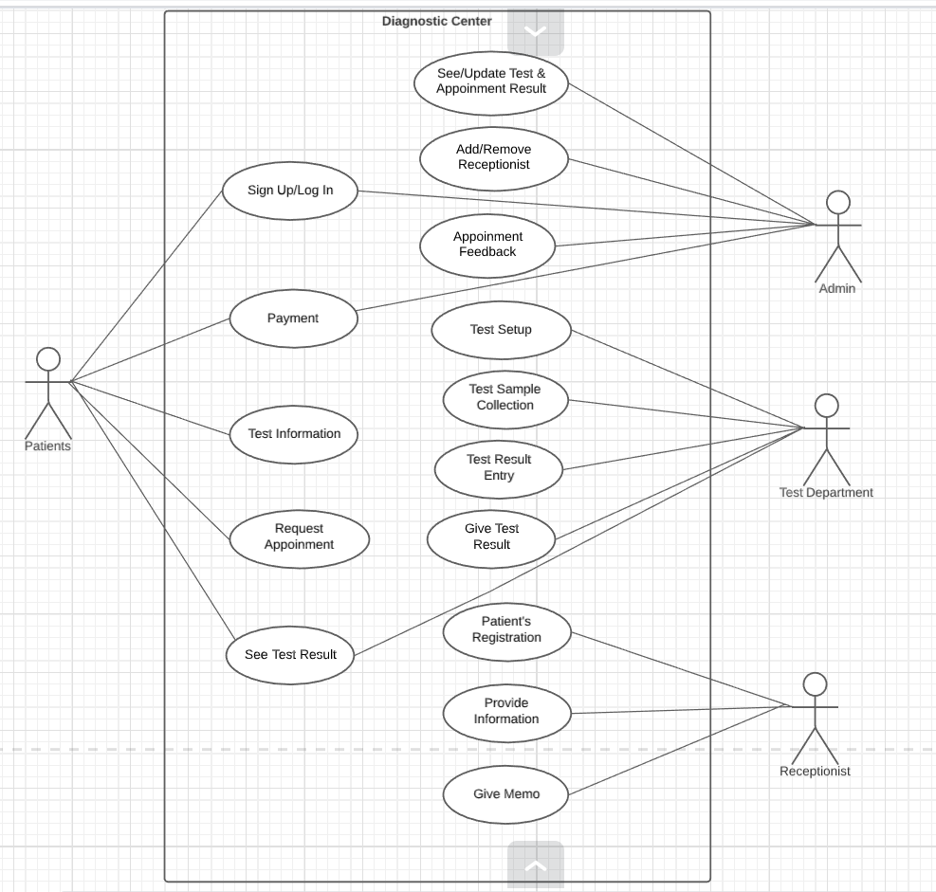

**Figure: Use Case Diagram**

***3.4.1.1* *Individual Actor***

***3.4.1.1.1 Patients***

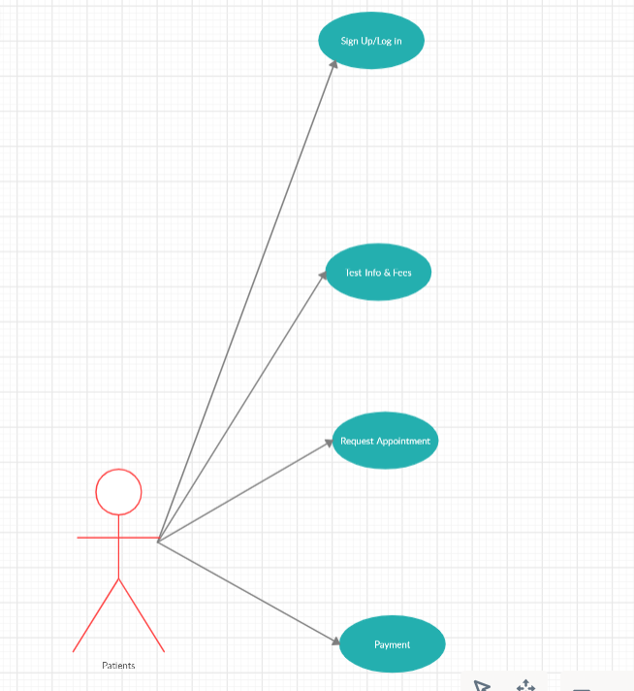

***3.4.1.1.2 Admin***

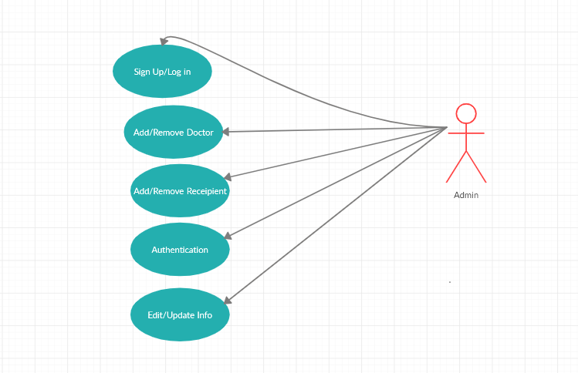

***3.4.1.1.3 Test Department***

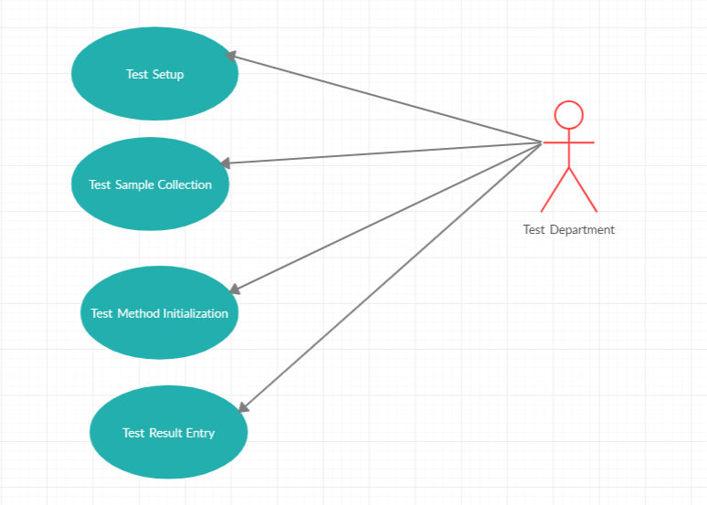

***3.4.1.1.4 Receptionist***

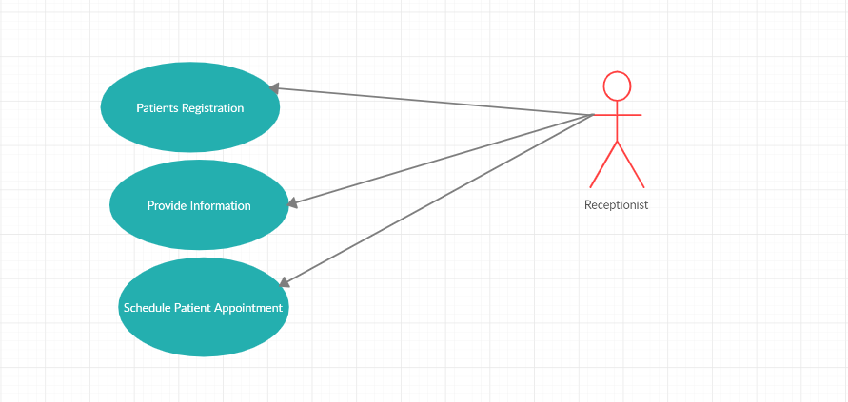

***3.4.1.2 Patients Use Case***

***Use Case :*** *Request Appointment,Sign up/Sign in,Request Test info & fees and payment .*

***Description :*** *The patients can request appointment,gets test info and fees and see their payment receipt.*

***3.4.1.3 Admin Use Case***

***Use Case :*** *Maintain system and check authentication.*

***Description :*** *The admin can perform update information,add or remove doctor,add or remove receptionist and check system authentication.*

***3.4.1.4 Test Department Use Case***

***Use Case :*** *Test sample collection and gives test result.*

***Description :*** *The test department collects test sample and gives test result.*

***3.4.1.5 Receptionist Use Case***

***Use Case :*** *Provide information.*

***Description :*** *The receptionist provides information and give schedule for patient appointment.*

**Use case Descriptions:**

**Appointment Request.**

|  |  |
| --- | --- |
| **Use Case Name:** | Appointment Request |
| **Brief Description:** | *The patients can request appointment for getting information of test.* |
| **Priority** | Essential |
| **Trigger** | Patient choose to create a new entry. |
| **Precondition** | Patient must be connected to the Internet  and on the DCMS page. |
| **Basic Path** | 1. Patient click on appointment request.  2.The server send the result to the admin.. |
| **Alternate Path** | N/A |
| **Post condition** | A record is created in the Admin Table of  the Admin Database |
| **Exception Path** | 1. If the connection is terminated before the  form is submitted, the fields are cleared  and the Server is returned  to the wait state. |

**Give Test Information**

|  |  |
| --- | --- |
| **Use Case Name:** | Give Test Information |
| **Brief Description:** | *Admin can provide test information and others requirements* |
| **Priority** | Essential |
| **Trigger** | Admin choose to create a new entry. |
| **Precondition** | Admin must be connected to the Internet  and on the DCMS page. |
| **Basic Path** | 1. Admin click on Give info button.  2.The server send the result to the patients based on patient id.. |
| **Alternate Path** | N/A |
| **Post condition** | A record is created in the Admin Table of  the Admin Database |
| **Exception Path** | 1. If the connection is terminated before the  form is submitted, the fields are cleared  and the Server is returned  to the wait state. |

**Receive Payment with Patient id.**

|  |  |
| --- | --- |
| **Use Case Name:** | Receive Payment with Patient id. |
| **Brief Description:** | This operation permits Patient to give payment with patient |
| **Priority** | Essential |
| **Trigger** | Patient choose to create a new entry. |
| **Precondition** | Patient must be connected to the Internet  and on the DCMS page. |
| **Basic Path** | 1. Patient click on payment request button and the payment go to the bKash or DBBL no Admin provided.  2.Admin will click the ok button to confirm they have received the payment. |
| **Alternate Path** | N/A |
| **Post condition** | A record is created in the Admin Table of  the Admin Database |
| **Exception Path** | 1. If the connection is terminated before the  form is submitted, the fields are cleared  and the Server is returned  to the wait state. |

**Making cash memo with Patient id.**

|  |  |
| --- | --- |
| **Use Case Name:** | Making cash memo with Patient id |
| **Brief Description:** | This operation permits Receptionist to make the cash memo for the patients |
| **Priority** | Essential |
| **Trigger** | Receptionist choose to create a new entry. |
| **Precondition** | Receptionist must be connected to the Internet and on the Entries page. |
| **Basic Path** | 1.Receptionist click the button cash memo.  2.The server send him a form of cash memo with his patient id.  3.Receptionist fill it up for the patients. |
| **Alternate Path** | N/A |
| **Post condition** | A record is created in the Receptionist Database. |
| **Exception Path** | 1. If the connection is terminated before the  form is submitted, the fields are cleared  and the Server is returned  to the wait state. |

**Prescribe for test.**

|  |  |
| --- | --- |
| **Use Case Name:** | Prescribe for test. |
| **Brief Description:** | This operation permits Doctors to give prescribe test with patient id which is receive from the information providing by Admin |
| **Priority** | Essential |
| **Trigger** | Doctors choose to create a new entry. |
| **Precondition** | Doctors must be connected to the Internet  and on the DCMS page. |
| **Basic Path** | 1. Doctors analysis the symptom based on patient id’s information. 2. click on Prescribe button and the prescription is prescribed in patients information based on patient id.   3.Receptionist will store the information on database. |
| **Alternate Path** | N/A |
| **Post condition** | A record is created in the Admint Table of  the Admin Database |
| **Exception Path** | 1. If the connection is terminated before the  form is submitted, the fields are cleared  and the Server is returned  to the wait state. |

**Gives Test Result.**

|  |  |
| --- | --- |
| **Use Case Name:** | Gives Test Result. |
| **Brief Description:** | This operation permits Test department to give test result with patient id which is receive from the information providing by admin |
| **Priority** | Essential |
| **Trigger** | Test Department choose to create a new entry. |
| **Precondition** | Test department must be connected to the Internet  and on the DCMS page. |
| **Basic Path** | 1. Test Department perform test based on patient id providing by admin. 2. The test result provides based on patient id.   3.Admin will store the information on database. |
| **Alternate Path** | N/A |
| **Post condition** | A record is created in the Admin Table of  the Admin Database |
| **Exception Path** | 1. If the connection is terminated before the  form is submitted, the fields are cleared  and the Server is returned  to the wait state. |

**Provides all information**

|  |  |
| --- | --- |
| **Use Case Name:** | Provides all information |
| **Brief Description:** | This operation permits Receptionist to give all of the result with patient id which is receive from the information providing by admin |
| **Priority** | Essential |
| **Trigger** | Receptionist choose to create a new entry. |
| **Precondition** | Receptionist must be connected to the Internet  and on the DCMS page. |
| **Basic Path** | 1. Receptionist perform all of the information based on patient id providing by admin. 2. All result provides based on patient id.   3.Receptionist will store the information on database. |
| **Alternate Path** | N/A |
| **Post condition** | A record is created in the Receptionist Table of  the Receptionist Database |
| **Exception Path** | 1. If the connection is terminated before the  form is submitted, the fields are cleared  and the Server is returned  to the wait state. |

***4 Other Non-functional Requirements***

***4.1 Performance requirements***

The performance of the project is at its best when the following are regularly done:

• Valid Information

• Password Management

• Regular Database Archiving

• Virus Protection

***4.2 Safety requirements***

Humans are error-prone, but the negative effects of common errors should be limited. E.g. users should realize that a given command will delete data, and be asked to confirm their intent or have the option to undo.

***4.3 Security Requirements***

Each member is required to enter an individual Username(Email ID) & password when accessing the software. Administrators have the option of increasing the level of password security their members must use. The data In the database is secured through multiple layers of Protection. One of those security layers involves member passwords. For maximum Security of your software, each member must protect their password.For accessing information valid information must be given by the user.This validation process are controlled by Admin.

***4.4 Software Quality Attributes***

The Quality of the system is maintained in such a way so that it can be very user-friendly. The software quality

attributes are assumed as under:

• Accurate and hence reliable.

• Secured.

• Fast Speed.

• Compatibility.

***4.5 Business Rules***

Business rule is a requirement that specifies the constraints or structure of a system. Effectively stating, organizing, and managing business rules will help ensure that the system can be appropriately applied. The

authority and user both cannot ignore these rules. The rules and regulations, the legal procedures, the cost of the system etc will follow this rules. Business rules have the right to make any decision or plan if necessary.

***4.6 Maintenance***

1.Maintaining patient’s prescription, medicine and diet advice details.

2.Providing billing details for indoor/outdoor patients.

3.Maintaining backup of data as per user requirements (between mentioned dates).

4.If user forgets his/her password then it can be retrieved by hint question.

5.In this project collection of data is from different pathology labs.

6Results of tests, prescription, precautions and diet advice will be automatically updated in the database.

7.Related test reports, patient details report, prescription and billing reports can be generated as per user requirements.

8.User or Administrator can search a patient’s record by his/her name or their registration date.

***5 Other Requirements***

5.1 Appendix A: Glossary

5.2 EMR- Electronic Medical Report

5.3 MIS-Management Information System

5.4 Enum-Enumeration

5.5 API-Application Programming Interface

5.6 GUI-Graphical User Interface

5.7 LAN-Local Area Network

5.8 TCP-Transmission Control Protocol

5.9 IP-Internet Protocol

6.0 FTP-File Transfer Protocol